eMERGENT gAMING tECNOLOGIES

Checklist

# General Instructions

**The purpose of this documentation is to provide a guideline (and a reminder) of everything that is expected to be included on the final delivery for the assignment of emergent gaming technologies.**

**Assignment description:**

Design and development of a game related project which includes the use of at least one emergent technology.

The final product should clearly demonstrate:

1. A high level of computer human interaction beyond the use of traditional forms of input (keyboard, mouse) or output (display or audio) or
2. The creation and implementation of a tool capable of produce procedural generated content which can be used by external developers.

The written documentation consists of a combination of a design document and a critical self-evaluation of the design, development process and final product. Please refer to the assignment brief or report clinic PowerPoint presentation for a more detailed information.

**Assignment deadline:**

Friday December 14, 2018 at 14:00 in the I-center. Students can deliver the project in prior the deadline.

**Assignment delivery method:**

1. **USB drive** which includes a digital copy of all the provided documentation.
2. Printed documentation (Without including the programs’ code).

**Delivery of custom hardware:**

Please **DO NOT** deliver any custom hardware to the I-Center. Contact the module lecturer to arrange collection of the custom hardware.

# **Check List:** **include a printed and a digital copy of this completed form**

**Digital Copy: Please include the following items and deliver them in a USB drive.**

|  |  |
| --- | --- |
| **Item** | **Included?** |
| **Design Document** |  |
| **User Guide** |  |
| **Evaluation report** |  |
| **Unity project** |  |
| **Project Executable** |  |
| **Video evidence to show project’s functionality** |  |
| **If applicable: Android APK or IOS app** |  |
| **If applicable: Drivers for special hardware.** |  |
| **If applicable: Others (Like Vuforia trackers)** |  |

|  |  |
| --- | --- |
| **Item** | **Included?** |
| **Design Document** |  |
| **User Guide** |  |
| **Evaluation report** |  |
| **If applicable: Others (Like Vuforia trackers)** |  |

**Printed documentation**

# presentation tips

Please use the following guideline to improve overall presentation of the documentation:

1. Use screenshots and printed imagery to support documentation and to offer a better view of the project.
2. If applicable: Provide a list of commands (voice commands, library of gestures) which includes the required command and its effect on the application.
3. If using a large set of imagery, it is recommended to include a table of figures. (https://support.office.com/en-us/article/create-or-change-a-table-of-figures-3bfbf7e6-2346-42fb-9810-09c113e1cb60)
4. Provide proper labelling system.

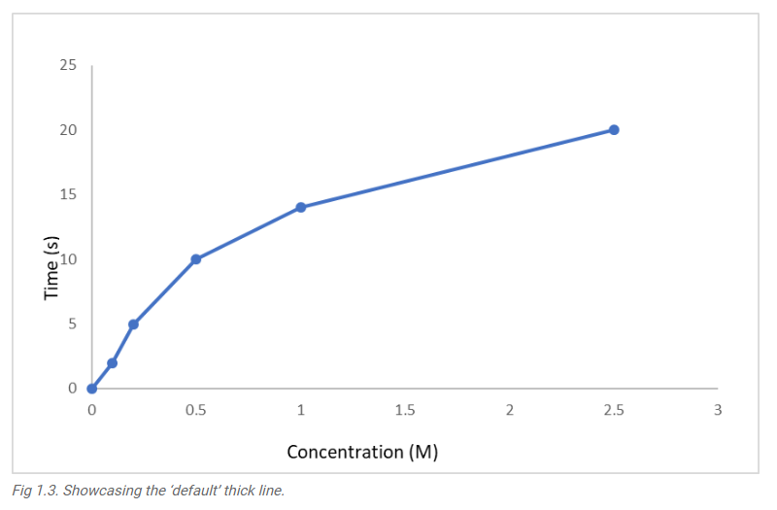

Label

Visual imagery (screen shots, graphs, tables, diagrams)



1. Use 2-sided text justification:
2. Include page number.
3. Include table of content.
4. Divide the documentation in sections to ease the reading process.
5. Keep consistency on point of view writing style (3rd person point of view is recommended for academic writing)

https://www.stlcc.edu/docs/student-support/academic-support/college-writing-center/point-of-view-in-academic-writing.pdf